- Access an EBSCO e-book
- When you choose to download, you will be directed to the following screen:
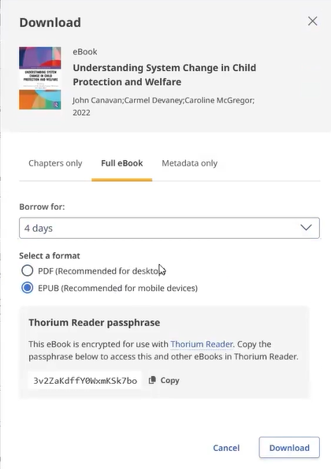

- When you choose Full eBook, see above screenshot, under Thorium Reader passphrase copy the passphrase by choosing Copy.
- Click Thorium Reader, highlighted in blue on the above screenshot.
- Follow the instructions to install the reader.

